DART LEARNING LAB

PROGRAM OUTPUT DEMONSTRATION
@github link
Team member: (Gad Anaclet Irumva - Kevia Mugabo)

DART LEARNING LAB - SCHOOL SYSTEMs

PART 1: FUNCTIONS
Codes:
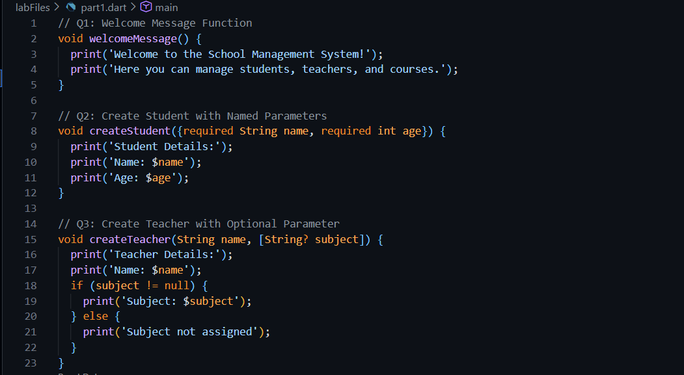
Output:
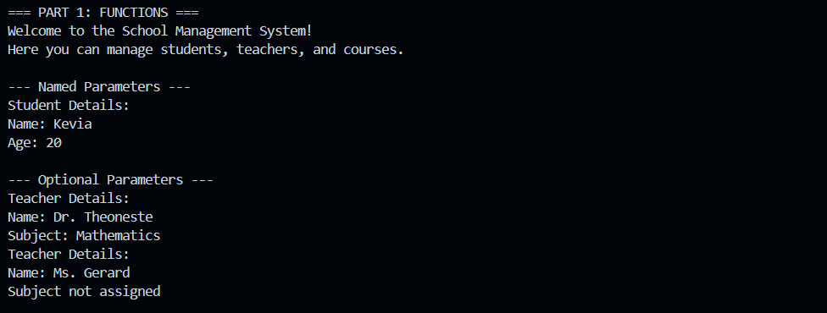

PART 2: CONSTRUCTORS AND CLASSES
Codes:
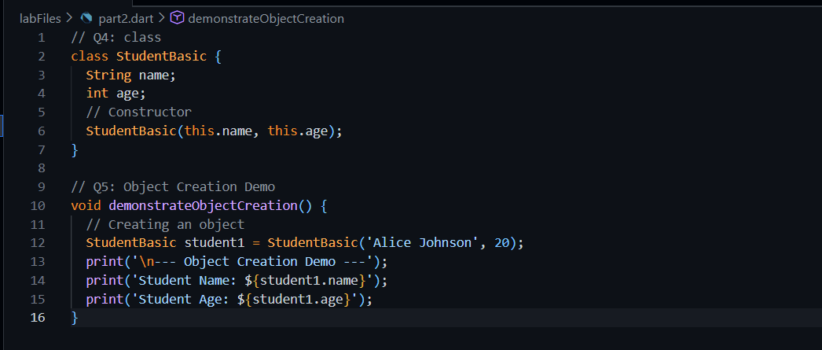
Output:
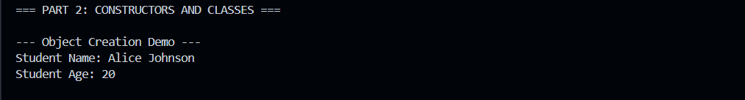

PART 3: INHERITANCE
Codes:
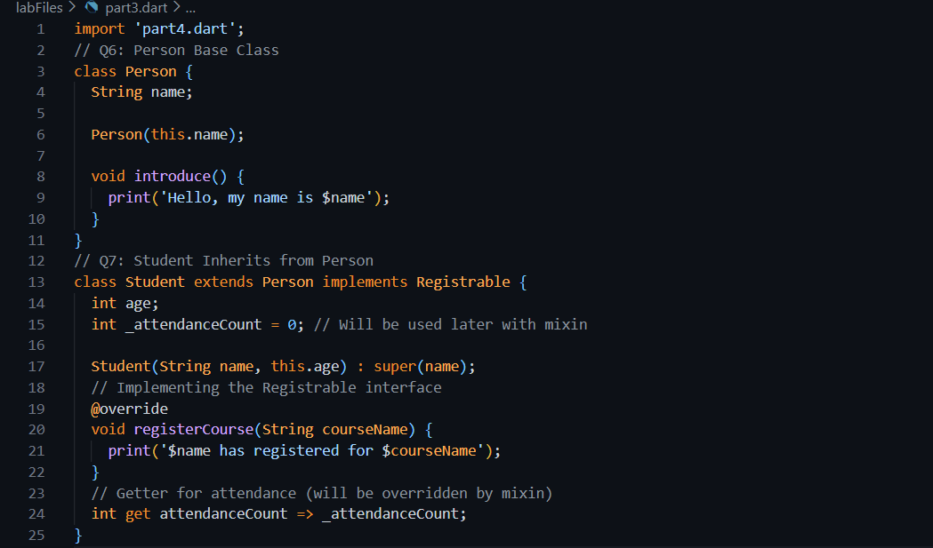
Output:

PART 4: INTERFACES
Codes:
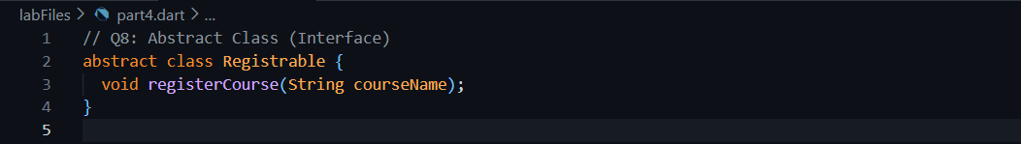
Output:


PART 5: MIXINS
Codes:
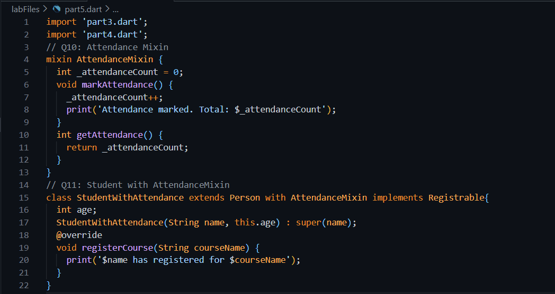
Output:
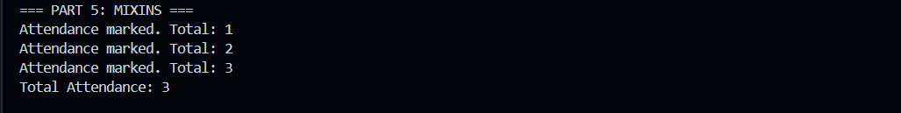

PART 6: COLLECTIONS
Codes:
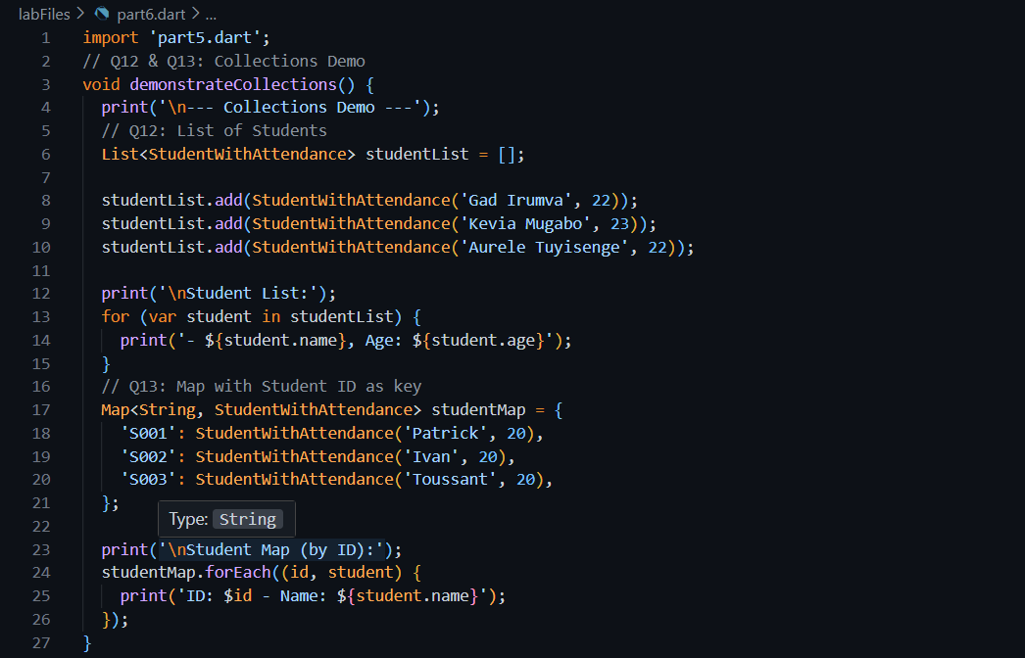
Output:
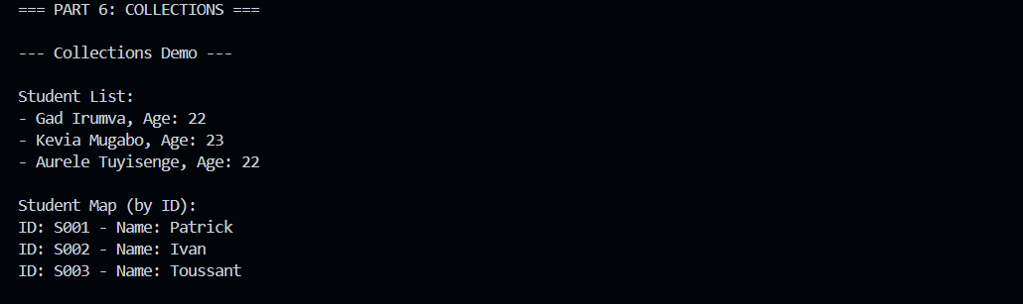

PART 7: ANONYMOUS AND ARROW FUNCTIONS
Codes:
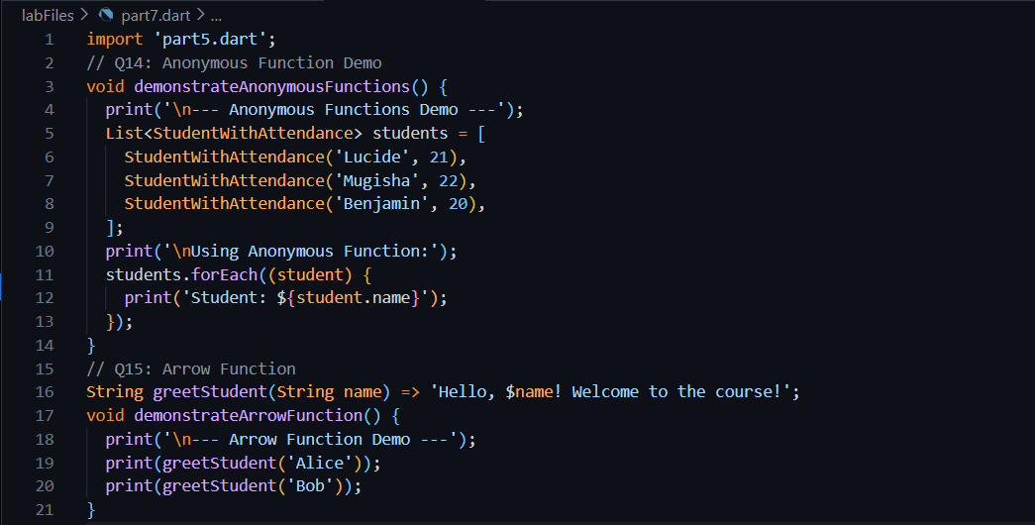
Output:
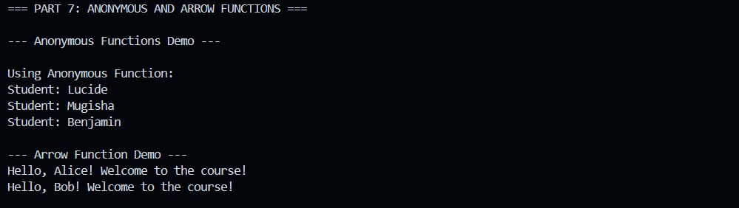

PART 8: ASYNCHRONOUS PROGRAMMING
Codes:
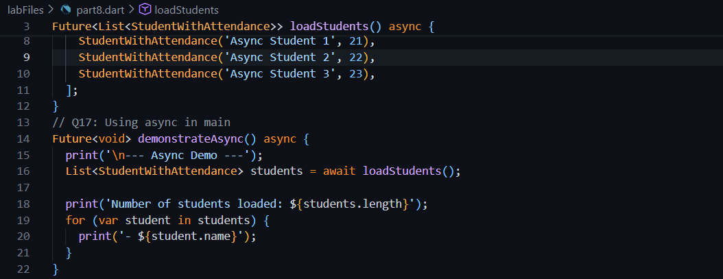

Output:
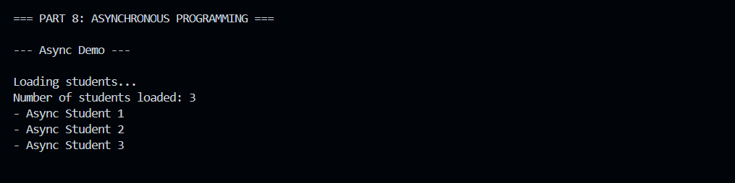

PART 9: INTEGRATION CHALLENGE
Codes:
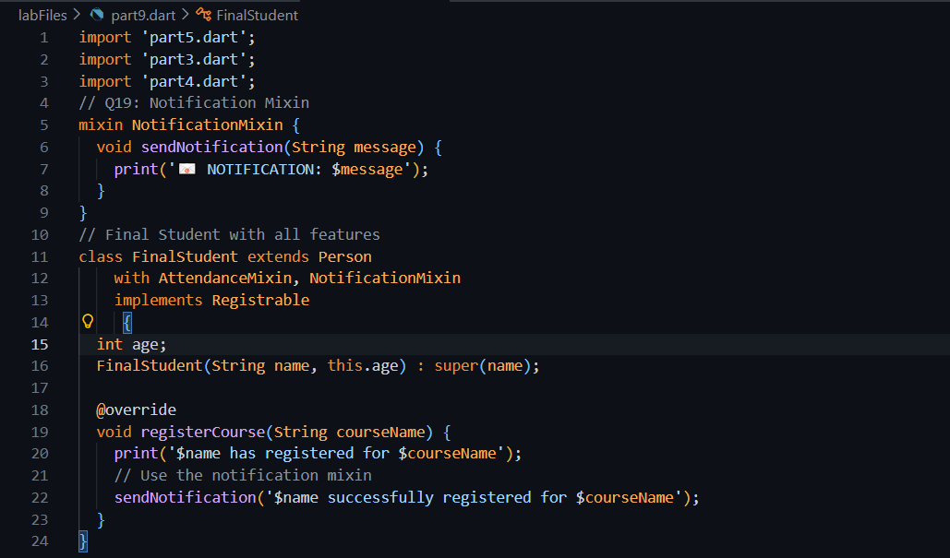
Output:
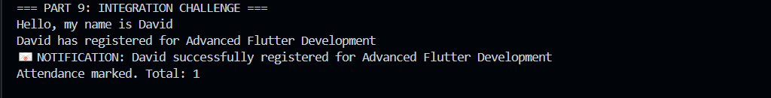
LAB COMPLETED SUCCESSFULLY!

